**Task 1**

* How did you use connection pooling?

*Answer:*

*We encapsulate Connection Pooling function in a class called DBReadConnector. This class’s static function returns a Connection object, so that we can reuse it.*

*We add the database source to context.xml and declare it in web.xml so that the java code could find the source by context.*

*The detailed configuration and java file are listed as below:*

* File name, line numbers as in Github

***Codes*:**

[*cs122b-spring18-team-86*](https://github.com/UCI-Chenli-teaching/cs122b-spring18-team-86)*/*[*Project5*](https://github.com/UCI-Chenli-teaching/cs122b-spring18-team-86/tree/master/Project5)*/*[*src*](https://github.com/UCI-Chenli-teaching/cs122b-spring18-team-86/tree/master/Project5/src)*/*[*servlets*](https://github.com/UCI-Chenli-teaching/cs122b-spring18-team-86/tree/master/Project5/src/servlets)*/DBReadConnector.java (all lines)*

[*cs122b-spring18-team-86*](https://github.com/UCI-Chenli-teaching/cs122b-spring18-team-86)*/*[*Project5*](https://github.com/UCI-Chenli-teaching/cs122b-spring18-team-86/tree/master/Project5)*/[src](https://github.com/UCI-Chenli-teaching/cs122b-spring18-team-86/tree/master/Project5/src)/*[*servlets*](https://github.com/UCI-Chenli-teaching/cs122b-spring18-team-86/tree/master/Project5/src/servlets)*/GetAllGenres.java (line 38)*

*cs122b-spring18-team-86/Project5/src/servlets/AutoComplete.java (line 52)*

*cs122b-spring18-team-86/Project5/src/servlets/JointSearch.java (line 144)*

*cs122b-spring18-team-86/Project5/src/servlets/MovieDetail.java (line 40)*

*cs122b-spring18-team-86/Project5/src/servlets/Search.java (line 120)*

*cs122b-spring18-team-86/Project5/src/servlets/StarDetail.java (line 57)*

*cs122b-spring18-team-86/Project5/src/servlets/VerifyCardServlet.java (line 47)*

*cs122b-spring18-team-86/Project5/src/servlets/VerifyPassword.java (line 43)*

***Configs*:**

[*cs122b-spring18-team-86*](https://github.com/UCI-Chenli-teaching/cs122b-spring18-team-86)*/*[*Project5*](https://github.com/UCI-Chenli-teaching/cs122b-spring18-team-86/tree/master/Project5)*/[WebContent](https://github.com/UCI-Chenli-teaching/cs122b-spring18-team-86/tree/master/Project5/WebContent)/*[*META-INF*](https://github.com/UCI-Chenli-teaching/cs122b-spring18-team-86/tree/master/Project5/WebContent/META-INF)*/context.xml (lines 15-18)*

[*cs122b-spring18-team-86*](https://github.com/UCI-Chenli-teaching/cs122b-spring18-team-86)*/*[*Project5*](https://github.com/UCI-Chenli-teaching/cs122b-spring18-team-86/tree/master/Project5)*/[WebContent](https://github.com/UCI-Chenli-teaching/cs122b-spring18-team-86/tree/master/Project5/WebContent)/*[*WEB-INF*](https://github.com/UCI-Chenli-teaching/cs122b-spring18-team-86/tree/master/Project5/WebContent/WEB-INF)*/web.xml (lines 21-31)*

* Snapshots showing use in your code (picture is too large, see it next page)

*DBReadConnector.java : 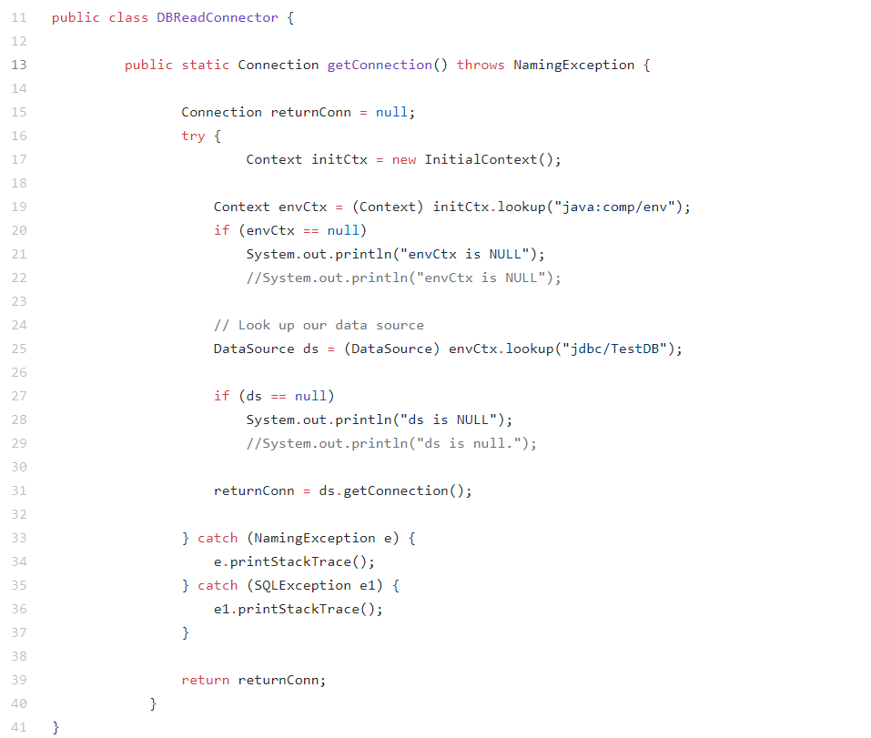*

*GetAllGenres.java*

*AutoComplete.java*

**

*JointSearch.java*

**

*MovieDetail.java*

**

*Search.java*

**

*StarDetail.java*

**

*VerifyCardServlet.java*

**

*VerifyPassword.java*

**

*context.xml*

**

*web.xml*

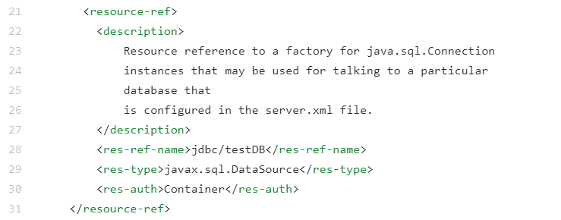

* How did you use Prepared Statements?

*Answer:*

*Prepare a “PreparedStatement” instance by database connection (“Connection” object) with a String, using question marks as parameters placeholder. Then fill values in question marks one by one. Execute it in the end.*

* File name, line numbers as in Github

*[cs122b-spring18-team-86](https://github.com/UCI-Chenli-teaching/cs122b-spring18-team-86)/*[*Project5*](https://github.com/UCI-Chenli-teaching/cs122b-spring18-team-86/tree/master/Project5)*/[src](https://github.com/UCI-Chenli-teaching/cs122b-spring18-team-86/tree/master/Project5/src)/*[*servlets*](https://github.com/UCI-Chenli-teaching/cs122b-spring18-team-86/tree/master/Project5/src/servlets)*/Search.java (lines 120-146)*

[*cs122b-spring18-team-86*](https://github.com/UCI-Chenli-teaching/cs122b-spring18-team-86)*/*[*Project5*](https://github.com/UCI-Chenli-teaching/cs122b-spring18-team-86/tree/master/Project5)*/[src](https://github.com/UCI-Chenli-teaching/cs122b-spring18-team-86/tree/master/Project5/src)/*[*servlets*](https://github.com/UCI-Chenli-teaching/cs122b-spring18-team-86/tree/master/Project5/src/servlets)*/****AutoComplete.java (lines 54-59)***

[*cs122b-spring18-team-86*](https://github.com/UCI-Chenli-teaching/cs122b-spring18-team-86)*/*[*Project5*](https://github.com/UCI-Chenli-teaching/cs122b-spring18-team-86/tree/master/Project5)*/[src](https://github.com/UCI-Chenli-teaching/cs122b-spring18-team-86/tree/master/Project5/src)/*[*servlets*](https://github.com/UCI-Chenli-teaching/cs122b-spring18-team-86/tree/master/Project5/src/servlets)*/****JointSearch.java (lines 146-179)***

[*cs122b-spring18-team-86*](https://github.com/UCI-Chenli-teaching/cs122b-spring18-team-86)*/*[*Project5*](https://github.com/UCI-Chenli-teaching/cs122b-spring18-team-86/tree/master/Project5)*/[src](https://github.com/UCI-Chenli-teaching/cs122b-spring18-team-86/tree/master/Project5/src)/*[*servlets*](https://github.com/UCI-Chenli-teaching/cs122b-spring18-team-86/tree/master/Project5/src/servlets)*/****MovieDetail.java (lines 48-56)***

[*cs122b-spring18-team-86*](https://github.com/UCI-Chenli-teaching/cs122b-spring18-team-86)*/*[*Project5*](https://github.com/UCI-Chenli-teaching/cs122b-spring18-team-86/tree/master/Project5)*/[src](https://github.com/UCI-Chenli-teaching/cs122b-spring18-team-86/tree/master/Project5/src)/*[*servlets*](https://github.com/UCI-Chenli-teaching/cs122b-spring18-team-86/tree/master/Project5/src/servlets)*/****StarDetail.java (lines 62-65)***

[*cs122b-spring18-team-86*](https://github.com/UCI-Chenli-teaching/cs122b-spring18-team-86)*/*[*Project5*](https://github.com/UCI-Chenli-teaching/cs122b-spring18-team-86/tree/master/Project5)*/*[*src*](https://github.com/UCI-Chenli-teaching/cs122b-spring18-team-86/tree/master/Project5/src)*/*[*servlets*](https://github.com/UCI-Chenli-teaching/cs122b-spring18-team-86/tree/master/Project5/src/servlets)*/****VerifyCardServlet.java (lines 55-58)***

[*cs122b-spring18-team-86*](https://github.com/UCI-Chenli-teaching/cs122b-spring18-team-86)*/*[*Project5*](https://github.com/UCI-Chenli-teaching/cs122b-spring18-team-86/tree/master/Project5)*/*[*src*](https://github.com/UCI-Chenli-teaching/cs122b-spring18-team-86/tree/master/Project5/src)*/*[*servlets*](https://github.com/UCI-Chenli-teaching/cs122b-spring18-team-86/tree/master/Project5/src/servlets)*/****VerifyPassword.java (lines 44-47)***

* Snapshots showing use in your code

(snapshot next page)

*Search.java*

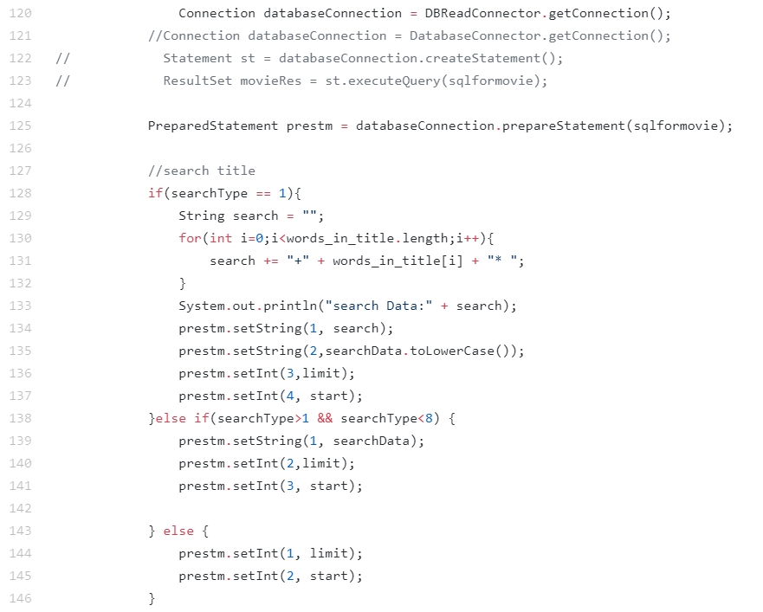

***AutoComplete.java***

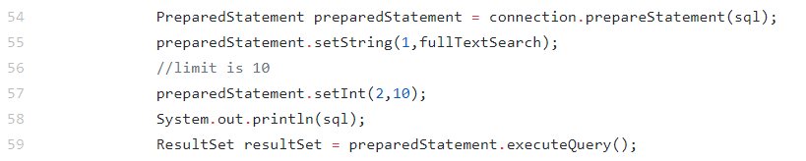

***JointSearch.java***

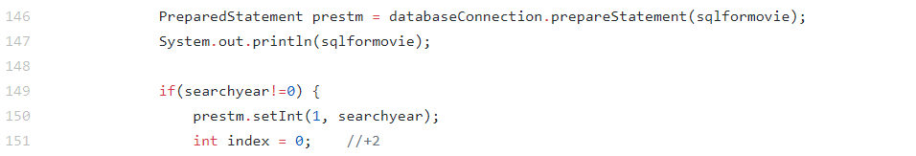

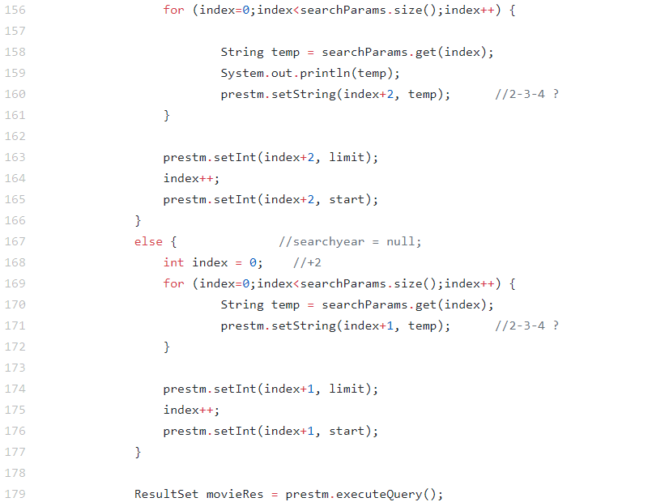

***MovieDetail.java***

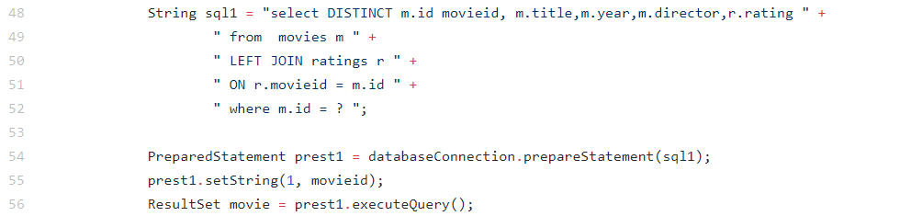

*StarDetail.java*

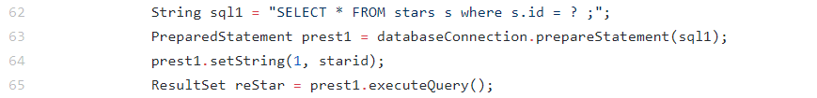

***VerifyCardServlet.java***

**

***VerifyPassword.java***



**Task 2**

* Address of AWS and Google instances

*Answer:*

*Aws:*

*Original :* [*54.153.65.169*](http://54.153.65.169)

*Master: 52.53.130.176*

*Slave: 13.56.139.125*

*Google:*

*35.196.2.204*

*We dropped our filter to receive the JMeter test queries. So you can access the project from the path below:*

*The project path is [ ip] /Project5/login.html*

* Have you verified that they are accessible? Does Fablix site get opened both on Google’s 80 port and AWS’ 8080 port?

*Answer:*

*They are verified altogether. Both ports are opened.*

* Explain how connection pooling works with two backend SQL (in your code)?

*Answer:*

*With two backend SQL, the servlets can select any of them as a database source. First we define 2 sources by name and ip address in context.xml and web.xml. After that, the only thing we need to do is to give the name of source when we read it from context in java codes.*

*Specifically, we pack the codes in 2 differnet classes to get connections from different MySQLs. They are called DBWriteConnector.java and DBReadConnector.java.*

* + File name, line numbers as in Github

***Codes****:*

*cs122b-spring18-team-86/*[*Project5*](https://github.com/UCI-Chenli-teaching/cs122b-spring18-team-86/tree/master/Project5)*/*[*src*](https://github.com/UCI-Chenli-teaching/cs122b-spring18-team-86/tree/master/Project5/src)*/*[*servlets*](https://github.com/UCI-Chenli-teaching/cs122b-spring18-team-86/tree/master/Project5/src/servlets)*/DBWriteConnector.java (all lines)*

[*cs122b-spring18-team-86*](https://github.com/UCI-Chenli-teaching/cs122b-spring18-team-86)*/Project5/[src](https://github.com/UCI-Chenli-teaching/cs122b-spring18-team-86/tree/master/Project5/src)/*[*servlets*](https://github.com/UCI-Chenli-teaching/cs122b-spring18-team-86/tree/master/Project5/src/servlets)*/AddMovie.java (line 66)*

[*cs122b-spring18-team-86*](https://github.com/UCI-Chenli-teaching/cs122b-spring18-team-86)*/Project5/*[*src*](https://github.com/UCI-Chenli-teaching/cs122b-spring18-team-86/tree/master/Project5/src)*/*[*servlets*](https://github.com/UCI-Chenli-teaching/cs122b-spring18-team-86/tree/master/Project5/src/servlets)*/DBReadConnector.java (all lines)*

[*cs122b-spring18-team-86*](https://github.com/UCI-Chenli-teaching/cs122b-spring18-team-86)*/Project5/[src](https://github.com/UCI-Chenli-teaching/cs122b-spring18-team-86/tree/master/Project5/src)/*[*servlets*](https://github.com/UCI-Chenli-teaching/cs122b-spring18-team-86/tree/master/Project5/src/servlets)*/GetAllGenres.java (line 38)*

*cs122b-spring18-team-86/Project5/src/servlets/AutoComplete.java (line 52)*

*cs122b-spring18-team-86/Project5/src/servlets/JointSearch.java (line 144)*

*cs122b-spring18-team-86/Project5/src/servlets/MovieDetail.java (line 40)*

*cs122b-spring18-team-86/Project5/src/servlets/Search.java (line 120)*

*cs122b-spring18-team-86/Project5/src/servlets/StarDetail.java (line 57)*

*cs122b-spring18-team-86/Project5/src/servlets/VerifyCardServlet.java (line 47)*

*cs122b-spring18-team-86/Project5/src/servlets/VerifyPassword.java (line 43)*

***Configs****:*

[*cs122b-spring18-team-86*](https://github.com/UCI-Chenli-teaching/cs122b-spring18-team-86)*/Project5/[WebContent](https://github.com/UCI-Chenli-teaching/cs122b-spring18-team-86/tree/master/Project5/WebContent)/*[*META-INF*](https://github.com/UCI-Chenli-teaching/cs122b-spring18-team-86/tree/master/Project5/WebContent/META-INF)*/context.xml lines 15-23)*

[*cs122b-spring18-team-86*](https://github.com/UCI-Chenli-teaching/cs122b-spring18-team-86)*/Project5/[WebContent](https://github.com/UCI-Chenli-teaching/cs122b-spring18-team-86/tree/master/Project5/WebContent)/*[*WEB-INF*](https://github.com/UCI-Chenli-teaching/cs122b-spring18-team-86/tree/master/Project5/WebContent/WEB-INF)*/web.xml (lines 21-42)*

* + Snapshots (next page)

*DBWriteConnector.java :* 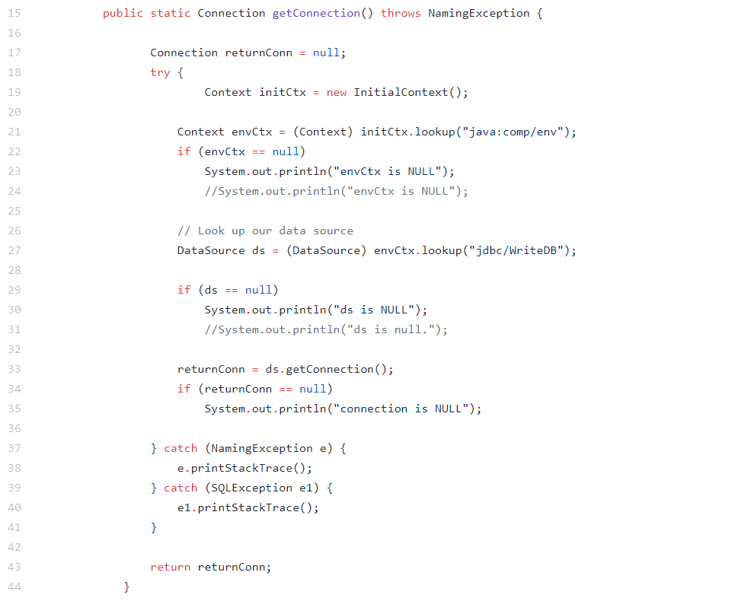

*In AddMovie.java*



*DBReadConnector.java :* 

*GetAllGenres.java*

*JointSearch.java*



*MovieDetail.java*



*Search.java*



*StarDetail.java*



*VerifyCardServlet.java*



*VerifyPassword.java*



*Context.xml*

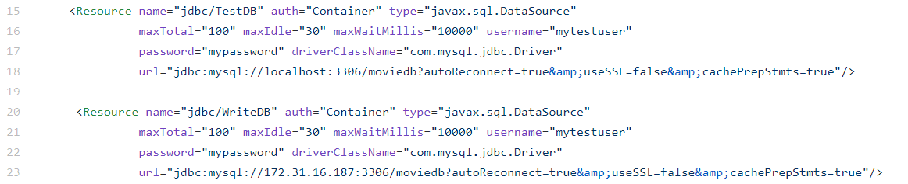

*Web.xml*

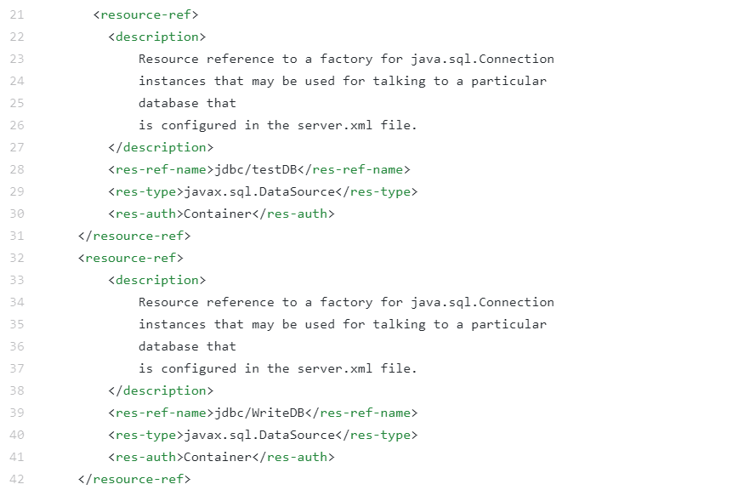

* How read/write requests were routed?

*Answer:*

*All the write/ insert request get connections from master’s source, which is named by “WriteDB” in context.xml . Read operations get connection of their localhost database, which is named “TestDB” in context xml.*

* + File name, line numbers as in Github

[*cs122b-spring18-team-86*](https://github.com/UCI-Chenli-teaching/cs122b-spring18-team-86)*/*[*Project5*](https://github.com/UCI-Chenli-teaching/cs122b-spring18-team-86/tree/master/Project5)*/[WebContent](https://github.com/UCI-Chenli-teaching/cs122b-spring18-team-86/tree/master/Project5/WebContent)/*[*META-INF*](https://github.com/UCI-Chenli-teaching/cs122b-spring18-team-86/tree/master/Project5/WebContent/META-INF)*/context.xml lines 15-23)*

[*cs122b-spring18-team-86*](https://github.com/UCI-Chenli-teaching/cs122b-spring18-team-86)*/*[*Project5*](https://github.com/UCI-Chenli-teaching/cs122b-spring18-team-86/tree/master/Project5)*/[WebContent](https://github.com/UCI-Chenli-teaching/cs122b-spring18-team-86/tree/master/Project5/WebContent)/*[*WEB-INF*](https://github.com/UCI-Chenli-teaching/cs122b-spring18-team-86/tree/master/Project5/WebContent/WEB-INF)*/web.xml (lines 21-42)*

* Snapshots

*Context.xml* 

*Web.xml*



**Task 3**

* Have you uploaded the log file to Github? Where is it located?
* Have you uploaded the HTML file (with all sections including analysis, written up) to Github? Where is it located?
* Have you uploaded the script to Github? Where is it located?
* Have you uploaded the WAR file and README to Github? Where is it located?